SQL Exercise - Advanced concepts

Exercise-1: Ranking and Window Functions

- Code:

Database Creation:

CREATE DATABASE OnlineRetailStore;
GO

USE OnlineRetailStore;
GO

CREATE TABLE Products (
ProductID INT IDENTITY(1,1) PRIMARY KEY,
ProductName NVARCHAR(100) NOT NULL,
Category NVARCHAR(50) NOT NULL,
Price DECIMAL(10,2) NOT NULL,
Brand NVARCHAR(50) NOT NULL,
StockQuantity INT DEFAULT 0,
CreatedDate DATETIME2 DEFAULT GETDATE()
);
GO

INSERT INTO Products (ProductName, Category, Price, Brand, StockQuantity) VALUES
-- Electronics Category
('iPhone 15 Pro', 'Electronics', 1199.99, 'Apple', 50),
('Samsung Galaxy S24', 'Electronics', 999.99, 'Samsung', 75),
('MacBook Pro 16"', 'Electronics', 2499.99, 'Apple', 25),
('Dell XPS 13', 'Electronics', 1299.99, 'Dell', 30),

-- Clothing Category
('Nike Air Max', 'Clothing', 129.99, 'Nike', 100),
('Levi''s 501 Jeans', 'Clothing', 89.99, 'Levis', 150),
('Adidas Ultraboost', 'Clothing', 180.00, 'Adidas', 80),
('North Face Jacket', 'Clothing', 249.99, 'North Face', 45),

-- Home & Garden Category
('Dyson V15 Vacuum', 'Home & Garden', 749.99, 'Dyson', 35),
('KitchenAid Mixer', 'Home & Garden', 399.99, 'KitchenAid', 25),
('Instant Pot Pro', 'Home & Garden', 149.99, 'Instant Pot', 60),
('Roomba i7+', 'Home & Garden', 599.99, 'iRobot', 15),

-- Sports Category
('Peloton Bike', 'Sports', 1445.00, 'Peloton', 10),
('Bowflex Dumbbells', 'Sports', 349.99, 'Bowflex', 25),
('Yoga Mat Premium', 'Sports', 79.99, 'Manduka', 150),
('Resistance Bands Set', 'Sports', 29.99, 'Fit Simplify', 200);
GO

SELECT 'Database and table created successfully!' AS Status;

SELECT
'Total Products: ' + CAST(COUNT(*) AS VARCHAR(10)) AS Summary
FROM Products;

SELECT
Category,
COUNT(*) AS ProductCount,
MIN(Price) AS MinPrice,
MAX(Price) AS MaxPrice
FROM Products
GROUP BY Category
ORDER BY Category;

Query:

USE OnlineRetailStore;
GO

SELECT 'ROW_NUMBER() - Assigns unique sequential ranks' AS RankingType;

SELECT
ProductID,
ProductName,
Category,
Price,
Brand,
ROW_NUMBER() OVER (PARTITION BY Category ORDER BY Price DESC) AS RowNum
FROM Products
ORDER BY Category, Price DESC;
GO

SELECT 'RANK() - Leaves gaps after tied ranks' AS RankingType;

SELECT
ProductID,
ProductName,
Category,
Price,
Brand,
RANK() OVER (PARTITION BY Category ORDER BY Price DESC) AS RankNum
FROM Products
ORDER BY Category, Price DESC;
GO

SELECT 'DENSE_RANK() - No gaps after tied ranks' AS RankingType;

SELECT
ProductID,
ProductName,
Category,
Price,
Brand,
DENSE_RANK() OVER (PARTITION BY Category ORDER BY Price DESC) AS DenseRankNum
FROM Products
ORDER BY Category, Price DESC;
GO

SELECT 'COMPARISON: All Three Ranking Functions' AS ComparisonType;

SELECT
ProductID,
ProductName,
Category,
Price,
Brand,
ROW_NUMBER() OVER (PARTITION BY Category ORDER BY Price DESC) AS RowNum,
RANK() OVER (PARTITION BY Category ORDER BY Price DESC) AS RankNum,
DENSE_RANK() OVER (PARTITION BY Category ORDER BY Price DESC) AS DenseRankNum
FROM Products
ORDER BY Category, Price DESC;
GO

SELECT 'TOP 3 Products per Category using ROW_NUMBER()' AS ResultType;

WITH RankedProducts AS (
SELECT
ProductID,
ProductName,
Category,
Price,
Brand,
StockQuantity,
ROW_NUMBER() OVER (PARTITION BY Category ORDER BY Price DESC) AS RowNum
FROM Products
)
SELECT
ProductID,
ProductName,
Category,
Price,
Brand,
StockQuantity,
RowNum
FROM RankedProducts
WHERE RowNum <= 3
ORDER BY Category, RowNum;
GO

SELECT 'TOP 3 Products per Category using RANK()' AS ResultType;

WITH RankedProducts AS (
SELECT
ProductID,
ProductName,
Category,
Price,
Brand,
StockQuantity,
RANK() OVER (PARTITION BY Category ORDER BY Price DESC) AS RankNum
FROM Products
)
SELECT
ProductID,
ProductName,
Category,
Price,
Brand,
StockQuantity,
RankNum
FROM RankedProducts
WHERE RankNum <= 3
ORDER BY Category, RankNum;
GO

SELECT 'TOP 3 Products per Category using DENSE_RANK()' AS ResultType;

WITH RankedProducts AS (
SELECT
ProductID,
ProductName,
Category,
Price,
Brand,
StockQuantity,
DENSE_RANK() OVER (PARTITION BY Category ORDER BY Price DESC) AS DenseRankNum
FROM Products
)
SELECT
ProductID,
ProductName,
Category,
Price,
Brand,
StockQuantity,
DenseRankNum
FROM RankedProducts
WHERE DenseRankNum <= 3
ORDER BY Category, DenseRankNum;
GO

- Output:

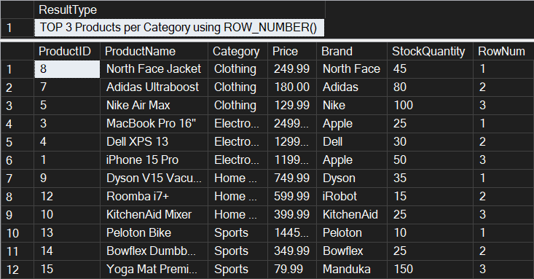

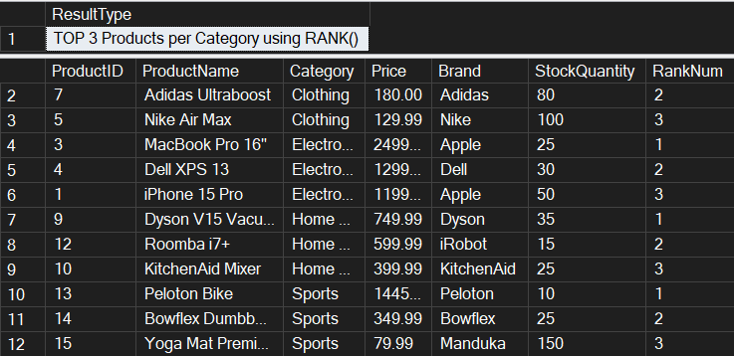

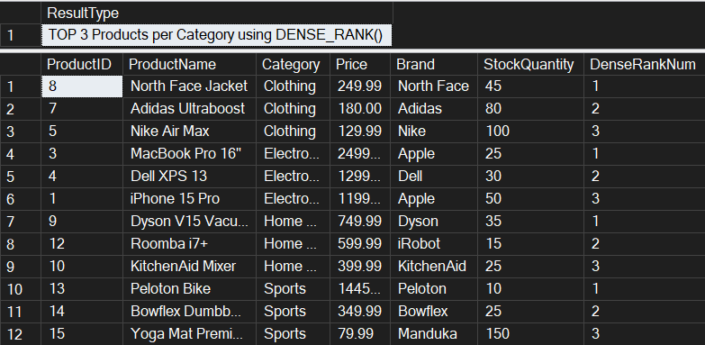
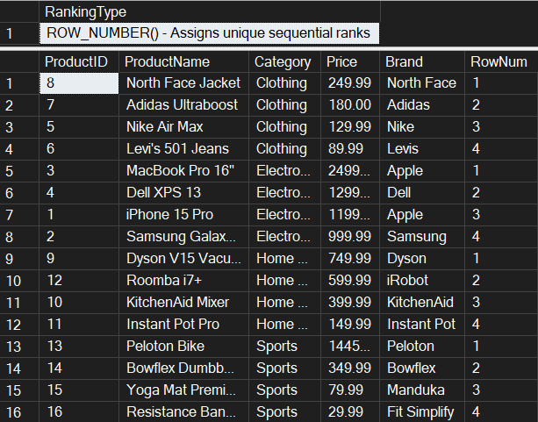

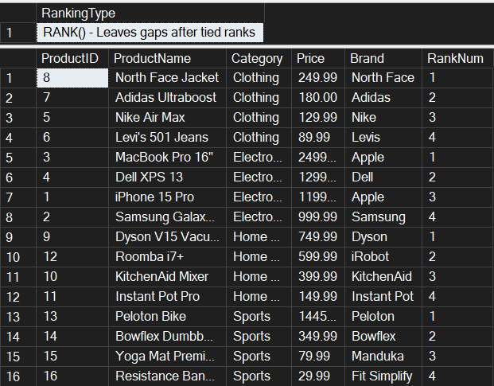

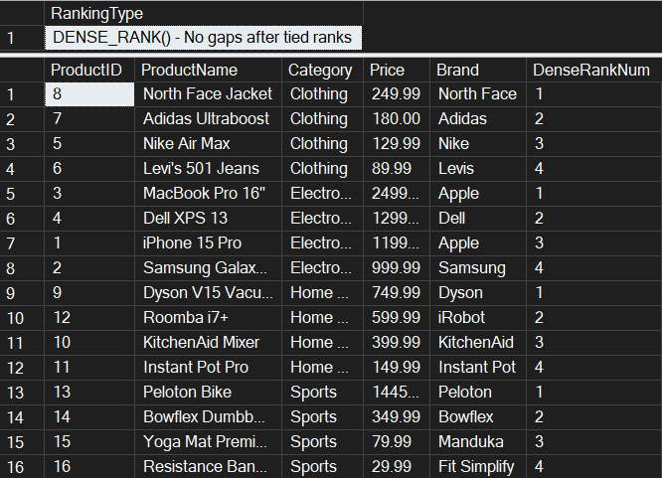

Exercise-4: Stored procedure

//Database Creation:

CREATE DATABASE EmployeeManagementSystem;
GO

USE EmployeeManagementSystem;
GO

CREATE TABLE Departments (
DepartmentID INT PRIMARY KEY,
DepartmentName VARCHAR(100)
);
GO

CREATE TABLE Employees (
EmployeeID INT PRIMARY KEY,
FirstName VARCHAR(50),
LastName VARCHAR(50),
DepartmentID INT FOREIGN KEY REFERENCES Departments(DepartmentID),
Salary DECIMAL(10,2),
JoinDate DATE
);
GO

INSERT INTO Departments (DepartmentID, DepartmentName) VALUES
(1, 'HR'),
(2, 'Finance'),
(3, 'IT'),
(4, 'Marketing');
GO

INSERT INTO Employees (EmployeeID, FirstName, LastName, DepartmentID, Salary, JoinDate) VALUES
(1, 'John', 'Doe', 1, 5000.00, '2020-01-15'),
(2, 'Jane', 'Smith', 2, 6000.00, '2019-03-22'),
(3, 'Michael', 'Johnson', 3, 7000.00, '2018-07-30'),
(4, 'Emily', 'Davis', 4, 5500.00, '2021-11-05'),
(5, 'Robert', 'Wilson', 1, 4800.00, '2020-05-12'),
(6, 'Sarah', 'Brown', 2, 6200.00, '2019-08-14'),
(7, 'David', 'Miller', 3, 7500.00, '2018-12-01'),
(8, 'Lisa', 'Anderson', 1, 5200.00, '2021-02-28'),
(9, 'Kevin', 'Taylor', 3, 6800.00, '2020-09-15'),
(10, 'Maria', 'Garcia', 4, 5800.00, '2021-06-10');
GO

Exercise-01: Create a Stored Procedure

- Code:

Use EmployeeManagementSystem;
GO

PRINT 'Creating Exercise 1 stored procedures...';

IF OBJECT_ID('sp_GetEmployeesByDepartment', 'P') IS NOT NULL
DROP PROCEDURE sp_GetEmployeesByDepartment;
GO

IF OBJECT_ID('sp_InsertEmployee', 'P') IS NOT NULL
DROP PROCEDURE sp_InsertEmployee;
GO

CREATE PROCEDURE sp_GetEmployeesByDepartment
@DepartmentID INT
AS
BEGIN
SET NOCOUNT ON;

-- Validate input
IF @DepartmentID IS NULL
BEGIN
RAISERROR('DepartmentID cannot be NULL', 16, 1);
RETURN;
END

-- Check if department exists
IF NOT EXISTS (SELECT 1 FROM Departments WHERE DepartmentID = @DepartmentID)
BEGIN
RAISERROR('Department with ID %d does not exist', 16, 1, @DepartmentID);
RETURN;
END

-- Return employee details
SELECT
e.EmployeeID,
e.FirstName,
e.LastName,
e.DepartmentID,
d.DepartmentName,
e.Salary,
e.JoinDate
FROM Employees e
INNER JOIN Departments d ON e.DepartmentID = d.DepartmentID
WHERE e.DepartmentID = @DepartmentID
ORDER BY e.LastName, e.FirstName;
END;
GO

-- Create sp_InsertEmployee
CREATE PROCEDURE sp_InsertEmployee
@FirstName VARCHAR(50),
@LastName VARCHAR(50),
@DepartmentID INT,
@Salary DECIMAL(10,2),
@JoinDate DATE
AS
BEGIN
-- Validate department exists
IF NOT EXISTS (SELECT 1 FROM Departments WHERE DepartmentID = @DepartmentID)
BEGIN
RAISERROR('Department with ID %d does not exist', 16, 1, @DepartmentID);
RETURN;
END

-- Get next available EmployeeID
DECLARE @NextEmployeeID INT;
SELECT @NextEmployeeID = ISNULL(MAX(EmployeeID), 0) + 1 FROM Employees;

-- Insert new employee
INSERT INTO Employees (EmployeeID, FirstName, LastName, DepartmentID, Salary, JoinDate)
VALUES (@NextEmployeeID, @FirstName, @LastName, @DepartmentID, @Salary, @JoinDate);
END;
GO
PRINT 'Stored procedures created successfully';
- Output:

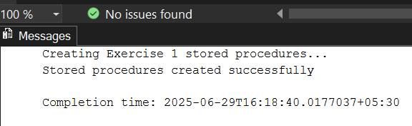

Exercise 5: Return Data from a Stored Procedure

- Code:

Use EmployeeManagementSystem;
GO

PRINT 'Creating Exercise 5 Stored Procedure...';

IF OBJECT_ID('sp_GetEmployeeCountByDepartment', 'P') IS NOT NULL
DROP PROCEDURE sp_GetEmployeeCountByDepartment;
GO

-- Create stored procedure that returns the total number of employees in a department
CREATE PROCEDURE sp_GetEmployeeCountByDepartment
@DepartmentID INT
AS
BEGIN
SET NOCOUNT ON;

-- Validate input parameter
IF @DepartmentID IS NULL
BEGIN
PRINT 'Error: DepartmentID cannot be NULL';
RETURN;
END

-- Check if department exists
IF NOT EXISTS (SELECT 1 FROM Departments WHERE DepartmentID = @DepartmentID)
BEGIN
PRINT 'Error: Department with ID ' + CAST(@DepartmentID AS VARCHAR(10)) + ' does not exist';
RETURN;
END

-- Declare variables for department info
DECLARE @DepartmentName VARCHAR(100);
DECLARE @EmployeeCount INT;

-- Get department name
SELECT @DepartmentName = DepartmentName
FROM Departments
WHERE DepartmentID = @DepartmentID;

-- Count employees in the specified department
SELECT @EmployeeCount = COUNT(*)
FROM Employees
WHERE DepartmentID = @DepartmentID;

-- Return the count as a result set
SELECT
@DepartmentID AS DepartmentID,
@DepartmentName AS DepartmentName,
@EmployeeCount AS TotalEmployees;

-- Also return individual employee details for reference
SELECT
'Employee Details:' AS Info,
e.EmployeeID,
e.FirstName + ' ' + e.LastName AS FullName,
e.Salary,
e.JoinDate
FROM Employees e
WHERE e.DepartmentID = @DepartmentID
ORDER BY e.LastName, e.FirstName;
-- Print summary message
PRINT 'Department: ' + @DepartmentName + ' has ' + CAST(@EmployeeCount AS VARCHAR(10)) + ' employees';
END;
GO

PRINT 'Exercise 5 stored procedure created successfully!';

-- TESTING THE STORED PROCEDURES
PRINT '=== TESTING EXERCISE 1 STORED PROCEDURES ===';

-- Test sp_GetEmployeesByDepartment
PRINT 'Testing sp_GetEmployeesByDepartment for HR Department (ID: 1):';
EXEC sp_GetEmployeesByDepartment @DepartmentID = 1;

PRINT '';
PRINT 'Testing sp_GetEmployeesByDepartment for IT Department (ID: 3):';
EXEC sp_GetEmployeesByDepartment @DepartmentID = 3;

PRINT '';
PRINT 'Testing sp_InsertEmployee - Adding a new employee:';
EXEC sp_InsertEmployee
@FirstName = 'Alice',
@LastName = 'Johnson',
@DepartmentID = 2,
@Salary = 6500.00,
@JoinDate = '2023-01-15';

PRINT '';
PRINT '=== TESTING EXERCISE 5 STORED PROCEDURE ===';

-- Test sp_GetEmployeeCountByDepartment for each department
PRINT 'Testing sp_GetEmployeeCountByDepartment for HR Department (ID: 1):';
EXEC sp_GetEmployeeCountByDepartment @DepartmentID = 1;

PRINT '';
PRINT 'Testing sp_GetEmployeeCountByDepartment for Finance Department (ID: 2):';
EXEC sp_GetEmployeeCountByDepartment @DepartmentID = 2;

PRINT '';
PRINT 'Testing sp_GetEmployeeCountByDepartment for IT Department (ID: 3):';
EXEC sp_GetEmployeeCountByDepartment @DepartmentID = 3;

PRINT '';
PRINT 'Testing sp_GetEmployeeCountByDepartment for Marketing Department (ID: 4):';
EXEC sp_GetEmployeeCountByDepartment @DepartmentID = 4;

-- ERROR TESTING

PRINT '';
PRINT '=== ERROR TESTING ===';

PRINT 'Testing with invalid department ID (999):';
EXEC sp_GetEmployeesByDepartment @DepartmentID = 999;

PRINT '';
PRINT 'Testing employee count with invalid department ID (999):';
EXEC sp_GetEmployeeCountByDepartment @DepartmentID = 999;

-- SUMMARY REPORT
PRINT '';
PRINT '=== FINAL SUMMARY ===';

SELECT 'DEPARTMENT SUMMARY:' AS ReportType;
SELECT
d.DepartmentID,
d.DepartmentName,
COUNT(e.EmployeeID) AS TotalEmployees,
AVG(e.Salary) AS AverageSalary,
MIN(e.Salary) AS MinSalary,
MAX(e.Salary) AS MaxSalary,
SUM(e.Salary) AS TotalSalaryBudget
FROM Departments d
LEFT JOIN Employees e ON d.DepartmentID = e.DepartmentID
GROUP BY d.DepartmentID, d.DepartmentName
ORDER BY d.DepartmentID;

- Output:

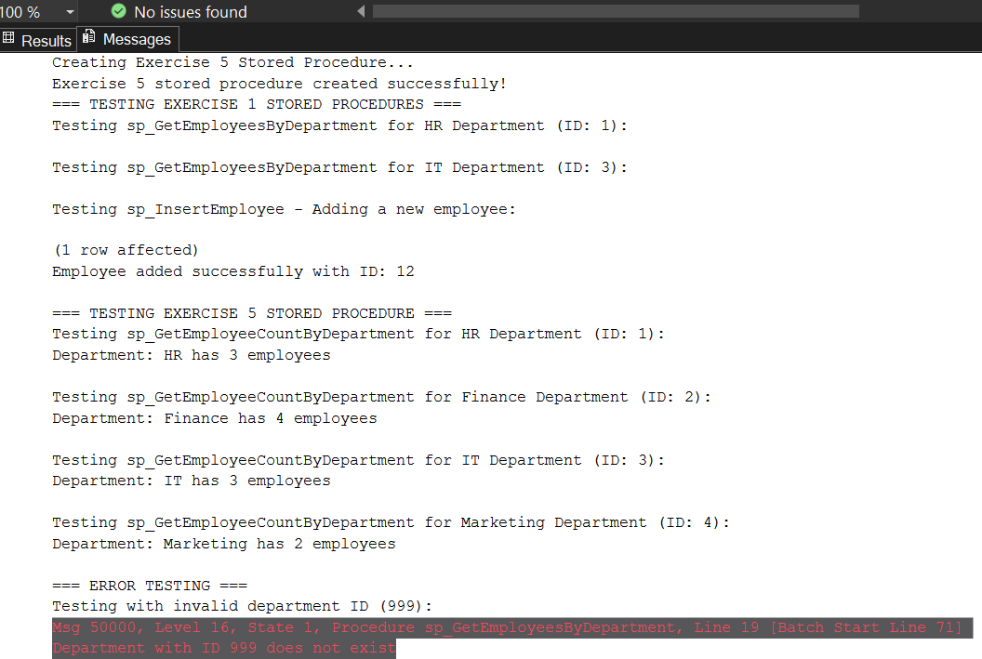
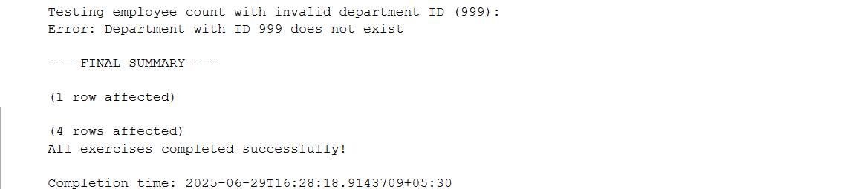

NUnit

- NUnit Hands-On: Unit Testing Calculator Operations

CalcLibrary/Calc.cs

using System;

namespace CalcLibrary
{
interface IMathLibrary
{
double Addition(double a, double b);
double Subtraction(double a, double b);
double Multiplication(double a, double b);
double Division(double a, double b);
}

public class SimpleCalculator : IMathLibrary
{
double result = 0;

public double Addition(double a, double b)
{
result = a + b;
return result;
}

public double Subtraction(double a, double b)
{
result = a - b;
return result;
}

public double Multiplication(double a, double b)
{
result = a * b;
return result;
}

public double Division(double a, double b)
{
if (b == 0)
throw new ArgumentException("Second Parameter Can't be Zero");
result = a / b;
return result;
}

public void AllClear()
{
result = 0;
}

public double GetResult
{
get { return result; }
}
}
}

CalcLibrary.Tests/CalculatorTests.cs

using NUnit.Framework;
using CalcLibrary;
using System;

namespace CalcLibrary.Tests
{
[TestFixture]
public class CalculatorTests
{
private SimpleCalculator _calc;

[SetUp]
public void Setup()
{
_calc = new SimpleCalculator();
}

[TestCase(2, 3, 5)]
[TestCase(-1, -2, -3)]
public void Addition_ShouldReturnCorrectSum(double a, double b, double expected)
{
var result = _calc.Addition(a, b);
Assert.That(result, Is.EqualTo(expected));
}

[TestCase(5, 3, 2)]
[TestCase(0, -2, 2)]
public void Subtraction_ShouldReturnCorrectResult(double a, double b, double expected)
{
var result = _calc.Subtraction(a, b);
Assert.That(result, Is.EqualTo(expected));
}

[TestCase(4, 2, 8)]
[TestCase(-1, 5, -5)]
public void Multiplication_ShouldReturnCorrectResult(double a, double b, double expected)
{
var result = _calc.Multiplication(a, b);
Assert.That(result, Is.EqualTo(expected));
}

[TestCase(10, 2, 5)]
public void Division_ShouldReturnCorrectResult(double a, double b, double expected)
{
var result = _calc.Division(a, b);
Assert.That(result, Is.EqualTo(expected));
}

[Test]
public void Division_ByZero_ShouldThrowException()
{
Assert.Throws<ArgumentException>(() => _calc.Division(5, 0));
}

[TearDown]
public void Cleanup()
{
_calc = null;
}
}
}

- Output:

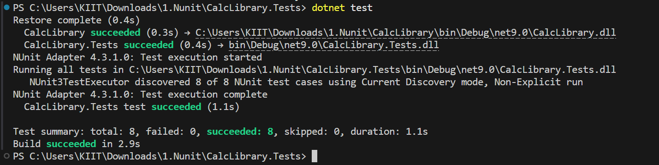

Moq

1. Write Testable Code with Moq :

CustomerCommLib / MailSender.cs

using System.Net;
using System.Net.Mail;

namespace CustomerCommLib
{
public interface IMailSender
{
bool SendMail(string toAddress, string message);
}

public class MailSender : IMaiSender
{
public bool SendMail(string toAddress, string message)
{
MailMessage mail = new MailMessage();
SmtpClient SmtpServer = new SmtpClient("smtp.gmail.com");

mail.From = new MailAddress("your_email_address@gmail.com");
mail.To.Add(toAddress);
mail.Subject = "Test Mail";
mail.Body = message;

SmtpServer.Port = 587;
SmtpServer.Credentials = new NetworkCredential("username", "password");
SmtpServer.EnableSsl = true;

SmtpServer.Send(mail);
return true;
}
}

public class CustomerComm
{
IMailSender _mailSender;

public CustomerComm(IMailSender mailSender)
{
_mailSender = mailSender;
}

public bool SendMailToCustomer()
{
_mailSender.SendMail("cust123@abc.com", "Some Message");
return true;
}
}
}

CustomerComm.Tests/CustomerCommTests.cs

using Moq;
using NUnit.Framework;
using CustomerCommLib;

namespace CustomerComm.Tests
{
[TestFixture]
public class CustomerCommTests
{
private Mock<IMailSender> _mockMailSender;
private CustomerCommLib.CustomerComm _customerComm;

[OneTimeSetUp]
public void Setup()
{
_mockMailSender = new Mock<IMailSender>();
_mockMailSender.Setup(x => x.SendMail(It.IsAny<string>(), It.IsAny<string>())).Returns(true);
_customerComm = new CustomerCommLib.CustomerComm(_mockMailSender.Object);
}

[Test]
public void SendMailToCustomer_ShouldReturnTrue()
{
bool result = _customerComm.SendMailToCustomer();
Assert.IsTrue(result);
}
}
}

- Output:

